Assignment 1 (Linux Basic)

Sol 1:

Through mkkdir we are creating a dir named test_dir and then we enter in the directory using cd then using touch created example.txt and for confirmation we did ls after that check the pat of the file using realpath then we renamed the file using mv.

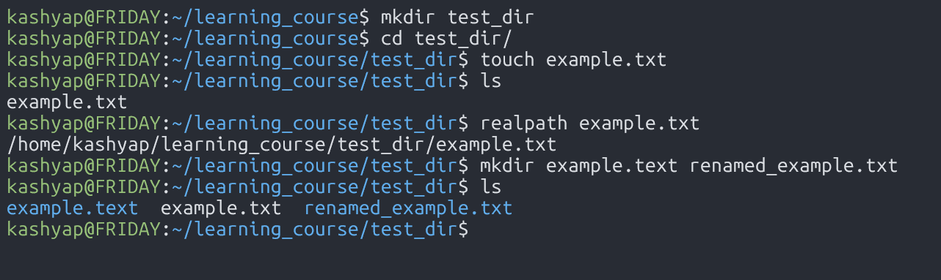

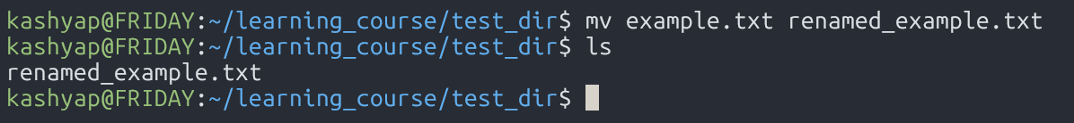

Sol 2:

We have check the content of the /etc/passwd using cat then we check first 5 then last 5 using head and tail command.  
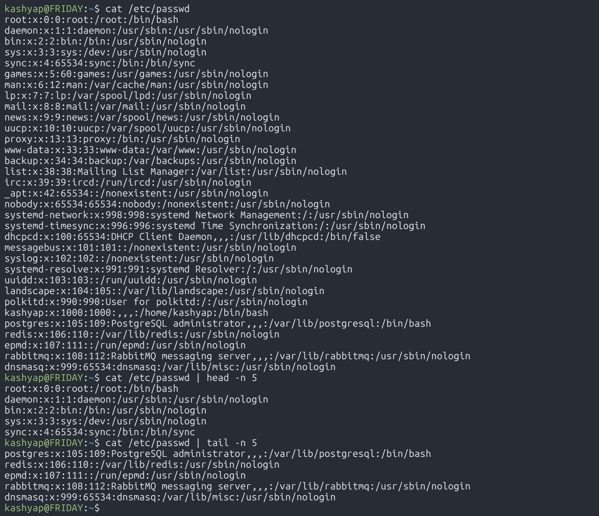

Sol 3:

We have filtered root from /etc/passwd using grep.

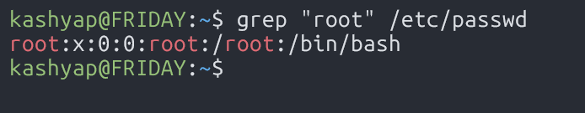

Sol 4:

We zipped the folder to test_dir.zip using zip command then we verified it with ls. We have unzipped it to the new directory using unzipped_dir then we confirmed it with ls.

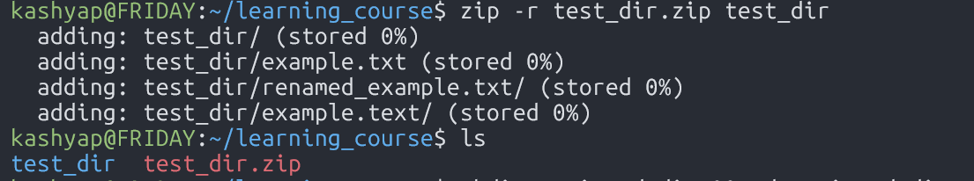

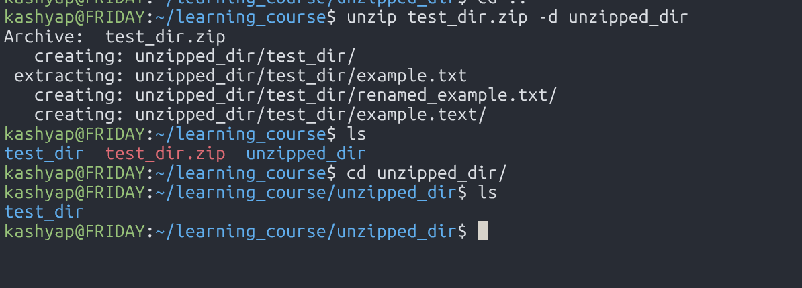

Sol 5:

Using wget I have downloaded a raw file from my repo of github.

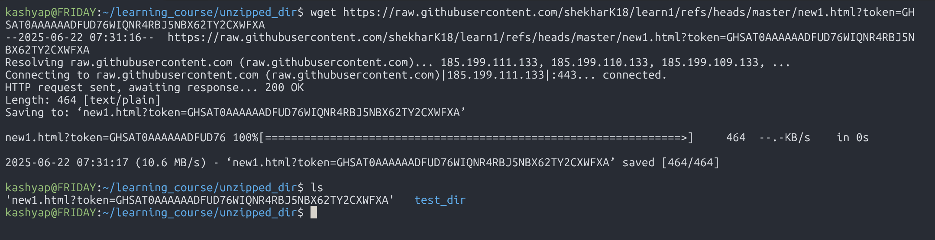

Repo link: <https://github.com/shekharK18/learn1>

Sol 6:

* Using touch created a secure.txt file then changed its ownership with chmod 444 as:
* **r** (read) = 4
* **w** (write) = 2
* **x** (execute) = 1

To get the total permission for a category, you sum the values.

So, for 444:

* **Owner:** 4 (read) = r--
* **Group:** 4 (read) = r--
* **Others:** 4 (read) = r--

Then with ll command we have verified the permission.

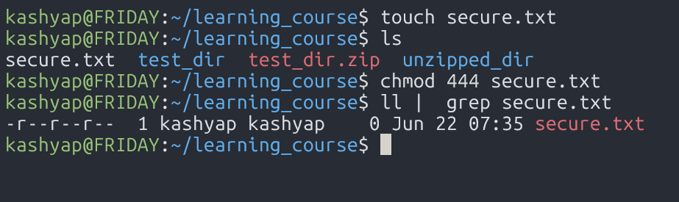

Sol 7:

With export we have created an environment and initialized Hello, Linux! And then echo it to verify.

